**CONCLUSION: -**

1. CH Gayle becomes player of the match most of the times followed by AB de Villiers.

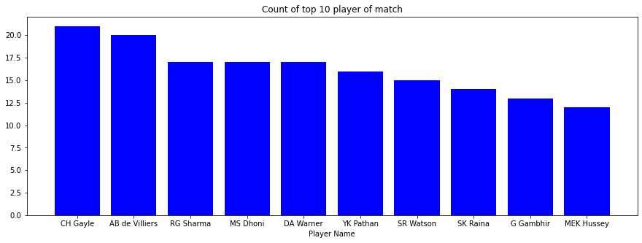

1. There are very rare case that a match will tie or end with no results.

1. Mumbai Indians wins toss most of the time followed by Kolkata Knight Riders.

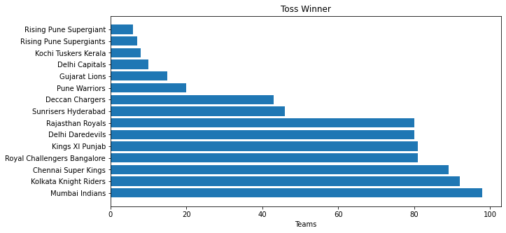

1. **Batting first: -** Most of the team wins by runs range between 0-20.

It is very rare that a team won by 60+runs.

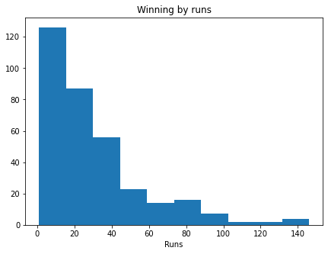

1. **Batting first: -** Mumbai Indians wins most of the time followed by Chennai Super Kings.

1. **Batting 2nd: -** Most of the team wins by wickets range between 4-6.

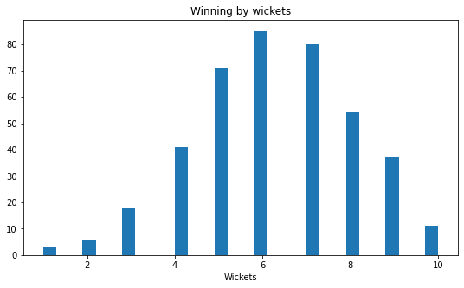

1. **Batting 2nd : -** Kolkata Knight Riders wins most of the time followed by Mumbai Indians.

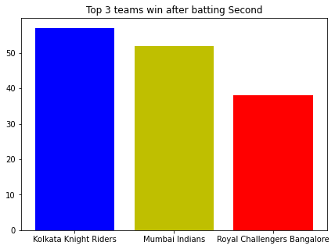

1. Most of the matches are played in Mumbai.

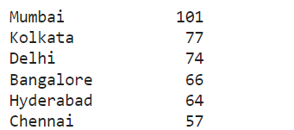

1. **Relation between toss win and match win**

Out of total 756 matches, the winner of toss and team are same for 393 matches

Which is around 50% approx.

So we can say toss does not make any effect on match winning.

1. Most of the runs are scored by running between the wickets.

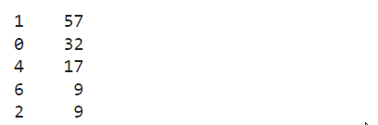

1. Most of the dismissal are due to **Caught.**

**Insights: -**

1. Home team has advantages in winning the match.
2. The batsman should be fit to run between the wickets as most runs scored by running between the wickets.
3. The team should focus on the catching skills of a player as it contributes in most of the wicket’s downfall.
4. Mumbai Indians is the most successful team.